# Noise Invader v3.0

Designed by Ghost Note Audio

Noise Invader is a “downward expander” plugin, designed specifically for noise suppression when playing an electric guitar through a virtual amplifier plugin. A downward expander can be thought of as a compressor working in reverse; instead of reducing gain when the input signal goes **above** a certain threshold, it reduces the gain when the input signal goes **below** a threshold.

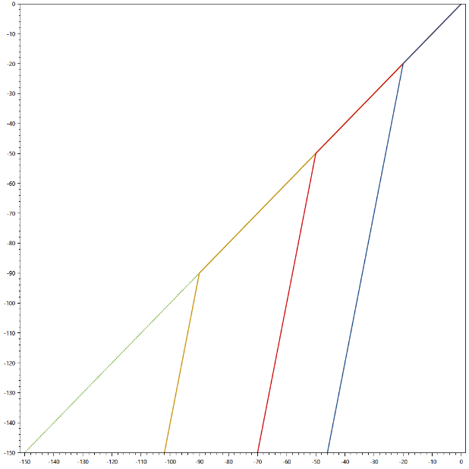

Example of how a downward expander affects gain.

## Installation

Installation is done by simply copying the NoiseInvader3_x64.dll file into your VST2 directory.

## Setup

Noise Invader works best if applied at the start of your signal chain, **before** any amp simulation or distortion effects.

## Parameters

**Threshold**

The level at which noise suppression starts to be applied. Typically, this is around -100 dB to -60 dB for most audio interfaces.

**Transition**

This is the width of the gain band over which downward expansion is applied. When set to zero, the plugin will work as a hard gate, and immediately apply the maximum gain reduction. When set to higher levels, the gain reduction is applied more gradually, resulting in more natural note decay.

**Expansion**

Sets the maximum gain reduction that the effect will apply. Values of 40-80dB are usually appropriate if the effect is placed before the gain stage, 20-40dB if placed after.

**Decay**

Controls how quickly the signal fades out when the gate closes. Set to a low value for a sharp, dry sound. Set to moderate or high level for a less processed, natural sound. Setting it too low may cause “chatter” where the gain may rapidly open and close when close to the threshold.

**Hysteresis**

Use this parameter to limit the amount of chatter (gain flickering up and down rapidly). Hysteresis prevents the gate from immediately re-opening after passing below the threshold, until it reaches an additional level of input gain.